
Cocoa Sugar Free Energy Bars

Prep (fridge time): 15mins (1-2 hours)

Perfect pre, post run or perfect on the go for those long runs. Simple to make and much better than sugar packed shop bought energy bars. They contain only natural sugar, they are rich in essential fats, fibre, B Vitamins, iron, magnesium, zinc and Omega-3.
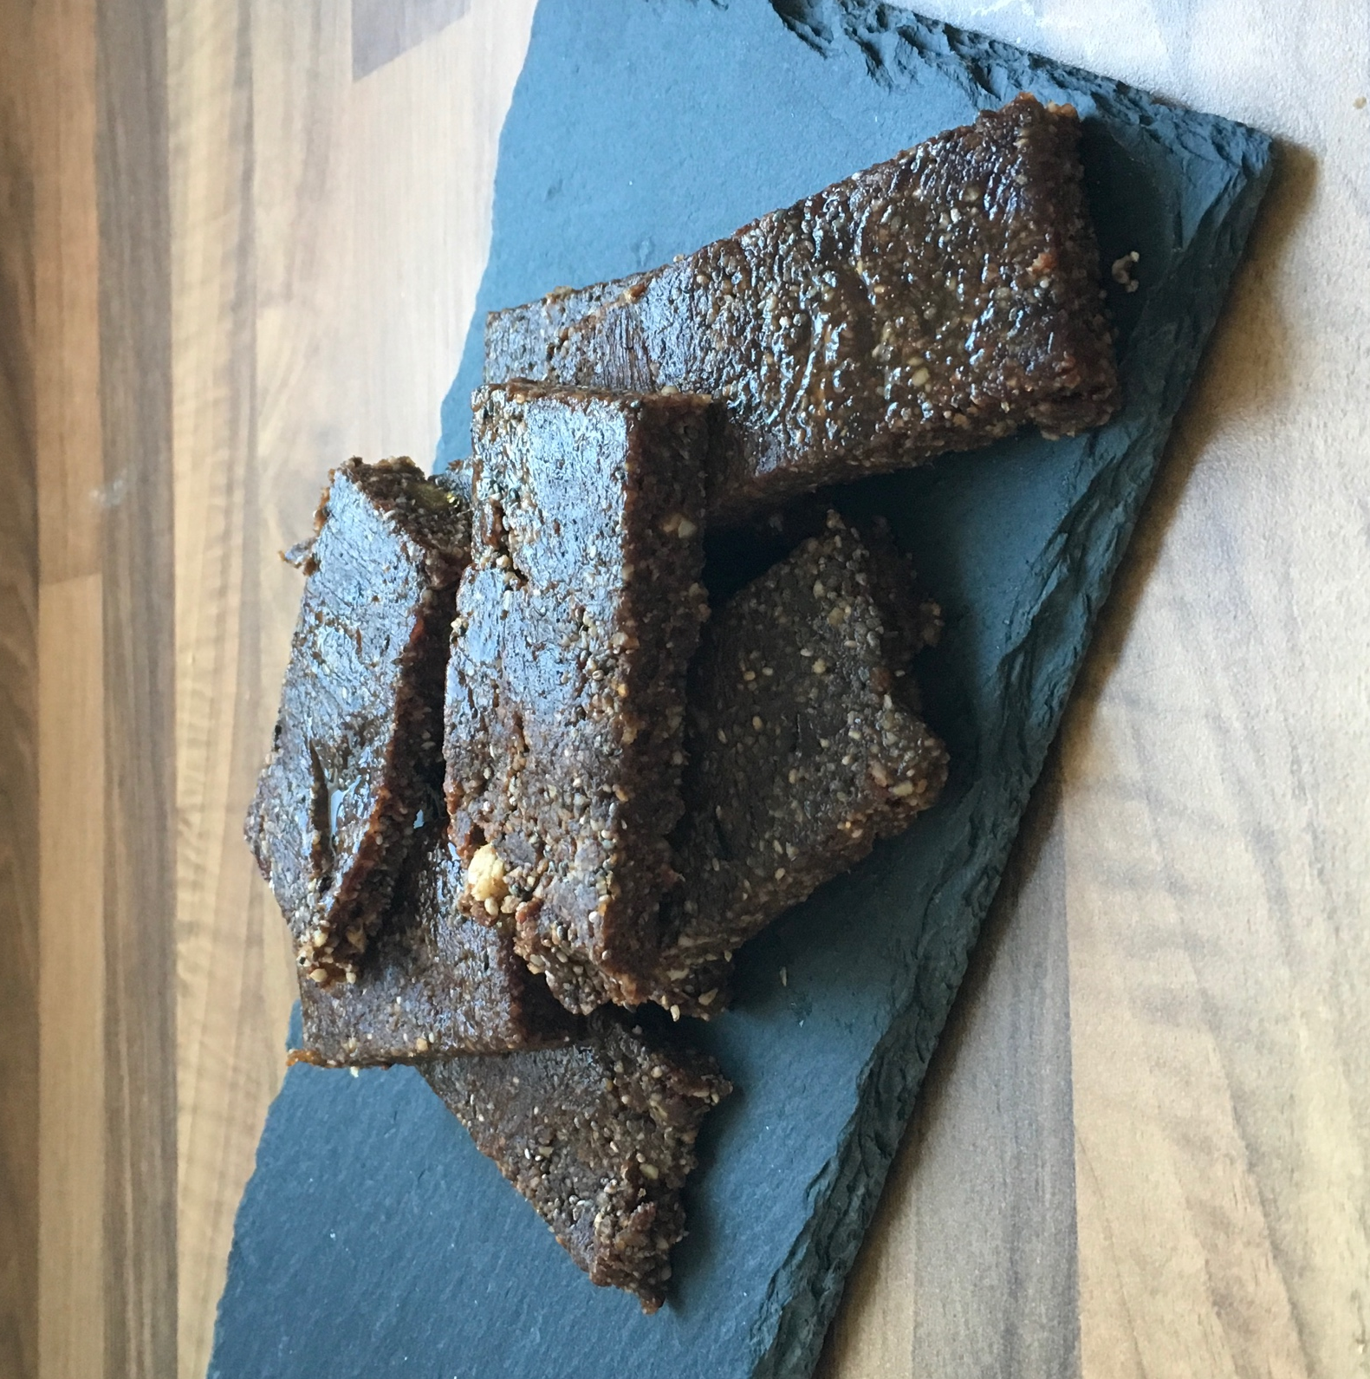
Ingredients
- 250g Ready to eat soft Dates
- 30g Chia Seeds
- 30g Other mixed seeds (e.g. flaxseeds)
- 230g Your favourite nuts (e.g. peanuts, almonds, cashews, hazelnuts etc)
- 2 tbsp cocoa powder
- 3 tbsp water
- Optional – drizzle of honey.

Method

- Put the dates, nuts, seeds and cocoa in food processor and blend to a crumble for about 2 minutes.
- Add the water and blend again, you may need to stop and scrap free the blender a few times.
- Continue to blend for a few minutes until all clumped together. Add more water if needed.
- Lay out sheet of cling film on a flat surface.
- Lay out mixture onto film and place another sheet of cling film over the top. Roll the mixture to 1cm thickness.
- Place flat into fridge for 1-2 hours until it is firm.
- Peel off cling film, drizzle honey over the top for extra sweetness and cut into pieces.
- Enjoy the guilt-free, tasty energy treat.
- Wrap any leftovers in cling film and keep in fridge.

Do share your images and comments of this recipe on AC Running and Fitness’s Facebook or Twitter Page. ‘Train Well, Eat Well, Live Well.’
Happy Running, Happy Cooking
Alex
AC Running and Fitness.

