

Lemony Courgette Spaghetti (with Prawns)

Prep and cooking time: 15-20 mins

One of my favourites – it’s packed full of flavour. Full of goodness and only takes 15minutes to rustle up. You can choose to add prawns to have that little bit extra or chicken if you prefer.
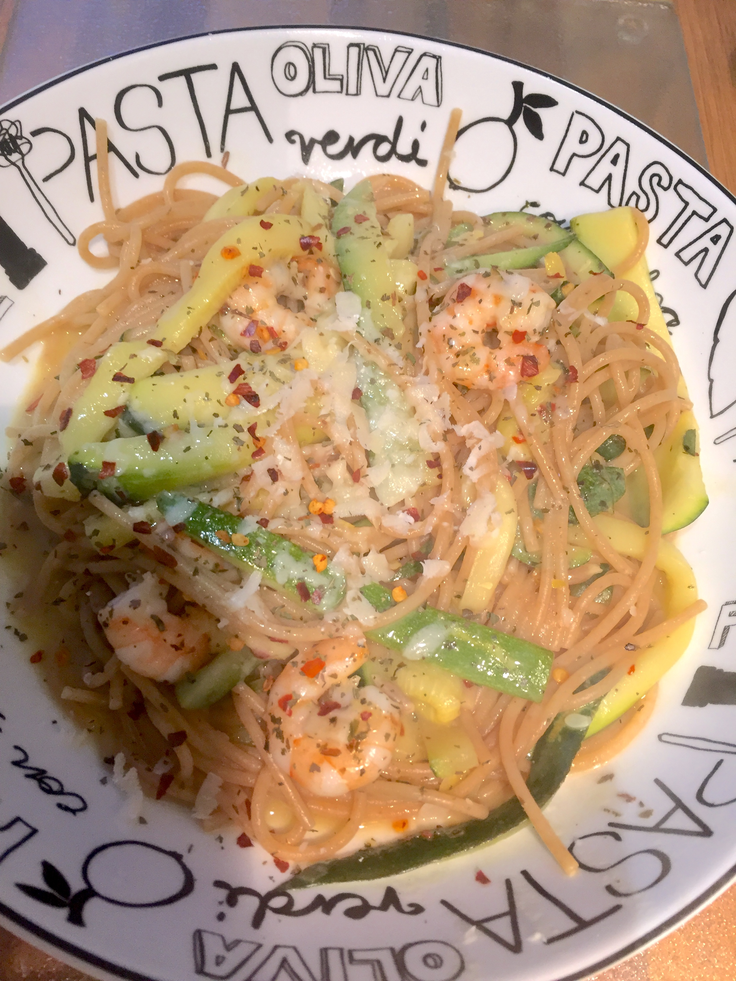
Ingredients
- 150g Whole-wheat spaghetti
- 2 Courgettes
- ½ Bunch of fresh mint or 2 tsp of dried mint
- 30g parmesan
- 1 lemon
- 1 tsp dried chilli flakes
- 2 garlic gloves
- Olive oil

Method

- Cook spaghetti in lightly salted water for 10minutes.
- While the spaghetti is cooking – slice the courgettes thinly into spaghetti like strips. Chop the garlic roughly. Fry garlic and courgette lightly in 1 tbsp of olive oil. Stirring often.
- Add in 1tsp of dried mint or half of your chopped up mint.
- When the spaghetti is al-dente place it in with the courgette. Keep the water – and tip half in with the courgette and spaghetti.
- Add in the remaining mint and 1 tsp of chilli flakes.
- Grate in the zest of half a lemon then squeeze in all the lemon juice.
- Grate in roughly 30g of parmesan and give it all a good stir.
- If you are using prawns add them in here and cook for 5 mins.
- Dish up, sprinkle a little parmesan, chilli flakes and mint on top and then tuck in!

Do share your images and comments of this recipe on AC Running and Fitness’s Facebook or Twitter Page. ‘Train Well, Eat Well, Live Well.’
Happy Running, Happy Cooking – Alex, AC Running and Fitness.

